CSA0502 – QUERY PROCESSING FOR DATASCIENCE
Lab Programs

19. Display the Dimensions (Shape) and Column Names of the World Alcohol Consumption Dataset
Aim
To display the dimensions (shape) of the World Alcohol Consumption dataset and extract the column names.
Code
import pandas as pd

# Create World Alcohol Consumption Dataset
data = {
"Country": ["India", "USA", "UK", "Australia", "Canada"],
"Year": [2020, 2020, 2021, 2021, 2022],
"Beverage": ["Beer", "Wine", "Beer", "Spirits", "Wine"],
"Consumption": [5.2, 8.1, 6.4, 7.3, 5.9]
}

df = pd.DataFrame(data)

print("World Alcohol Consumption Dataset")
print(df)

# Display shape
print("\nShape of Dataset:")
print(df.shape)

# Display column names
print("\nColumn Names:")
print(df.columns)
Output
World Alcohol Consumption Dataset

Country Year Beverage Consumption
0 India 2020 Beer 5.2
1 USA 2020 Wine 8.1
2 UK 2021 Beer 6.4
3 Australia 2021 Spirits 7.3
4 Canada 2022 Wine 5.9

Shape of Dataset:
(5, 4)

Column Names:
Index(['Country', 'Year', 'Beverage', 'Consumption'], dtype='object')
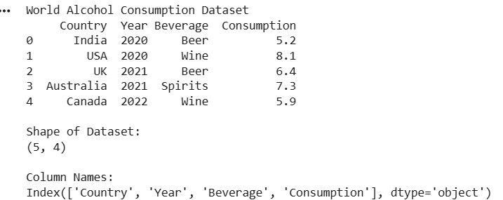
Result
The dimensions (shape) and column names of the World Alcohol Consumption dataset were displayed successfully.

20. Find the Index of a Given Substring in a DataFrame Column
Aim
To find the index of a given substring in a DataFrame column.
Code
import pandas as pd

# Create Dataset
data = {
"Name": ["Shashank", "Rahul", "Priya", "Anil", "Kiran"]
}

df = pd.DataFrame(data)

print("Original DataFrame")
print(df)

# Find substring "an"
result = df["Name"].str.find("an")

print("\nIndex of Substring 'an'")
print(result)
Output
Original DataFrame

Name
0 Shashank
1 Rahul
2 Priya
3 Anil
4 Kiran

Index of Substring 'an'

0 6
1 -1
2 -1
3 0
4 3
Name: Name, dtype: int64
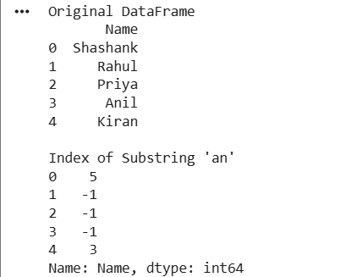
Result
The index position of the given substring was successfully found using the str.find() method. A value of -1 indicates that the substring was not found.

